**Ready Player One** IN 1105 G2 Java Project

**What you are to do:**

In this Project, you will write a Java Program to simulate a Video Game.

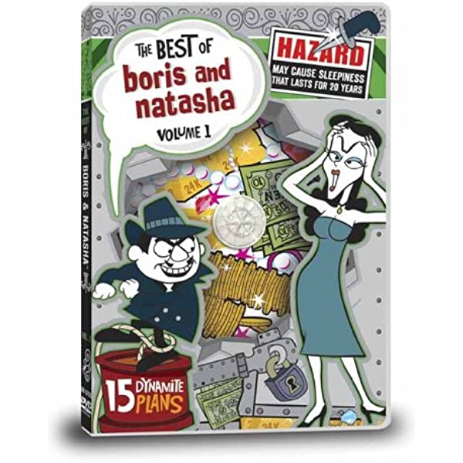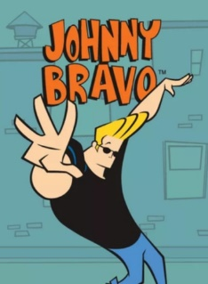

**The Hero, Johnny Bravo, is a member of Covert One, the Government’s most secret Spy Agency.**

**He is trying to arrest Boris Badenough, master Russian Spy, and his sidekick, Natasha Romanov.**

What you are to do:

Write a Java Program that meets the following specifications:

Class: GameRunner

Contains public static void main(String args[])

Starts the game and manages all the other method calls

Class: Hero

This is where you model Johnny Bravo.

Class: Villian

This is where you model Johnny Bravo.

Put methods and logic in Class Hero and Class Boris to simulate our Spys fighting with each other.

The Winner is the Last Man Standing.